ROYAL OAK INTERNATIONAL SCHOOL
Sr. Sec. C.B.S.E Affiliated
SESSION: 2019-20
Whole year syllabus of CLASS-VII
SUBJECT- ENGLISH

SUBJECT- ENGLISH

Month | No. of Days |  |  | Content |  | Activities | Worksheet
Apr. |  |  |  | New Images::  L-1.- Of magic lamps and Genies  Novel: Ch 1&2  Writing: Notice (Announcement),  Letter (Informal)  Grammar: Kinds of Sentences,  Determiners (Article and Quantifiers) |  | Reading: Of Magic lamps and Genies | Determiners ,  sentences,  Jumbled sentences, Notice
May |  |  |  | New Images:  L – 2 On the Grasshopper and the cricket (poem)  Writing: Message  Grammar: Present Tense, Preposition |  | Make a chart of Present tense (Group activity) | Tenses, Message,  Jumbled sentences
July |  |  |  | New Images:  Ch – 3 The Luncheon  Ch – 7 Just Me  Ch – 4 Somebody’s Mother (Poem)  Novel: Ch. 3,4, 8  Writing: Diary Entry, Dialogue writing  Grammar: Past Tense, Preposition, Adverb ,Editing |  | Prepare a chart of Past and Future tense (Group Activity) | Tenses, Adverb, Preposition, Dialogue writing,
WRITTEN EVALUATION SYLLABUS: P.A-I M.M. 40
Ch – 1,2,3 Writing : Notice (Announcement), Letter (Informal)
Grammar : Kinds of Sentences, Tense , Preposition, Pronouns Novel: Ch – 1,2,3
August |  | 25 |  |  | New Images:  Ch. -5 Father’s Help  Ch. – 6 Binya’s Blue Umbrella  Ch – 8 The boy with a catapult  Novel: Ch. 5,6  Writing: E-mail Writing, Formal Letter  Grammar: Future Tense, Active and Passive Voice | Prepare a chart of Voice Change |  | Unseen passage, Future Tense,  Voice
September |  | 4 |  |  | Writing: Poster making  Grammar: Modals | Make a poster on ‘Stop Child Labour’.
WRITTEN EVALUATION SYLLABUS: HALF YEARLY EXAM. M.M 80
Complete syllabus from April to August
October |  |  | 19 |  | New Images:  Ch -9. Adrif at sea  Ch - 10 As I grew older  Novel: 7,8  Writing: Advertisement, Factual description  Grammar: Conjunction, Non finite verbs | Speaking Skill: Summarize Adrif At Sea |  | Writing: Advertisement  Grammar: Conjunction, Use of to+ infinitive
November |  |  | 14 |  | New Images  Ch - 11. The face on the wall  Ch - 12. When the furniture went mad  Novel: 9  Writing: Article  Grammar: Narration (Assertive sentences) | Write an article on  Polythene: the dreadful element on earth |  | Narration
WRITTEN EVALUATION SYLLABUS: P.A-II M.M. 40
Complete syllabus covered in the month of Oct.
Writing : Article Grammar : Narration
December |  |  | 19 |  | New Images:  Ch -13. All the world’s a stage  Ch - 14. The Hunt  Ch – 16 To be a lady  Novel: Ch. 10, 11  Writing: Guided Paragraph  Grammar: Narration (imperative),  Clauses (main clause and subordinate clause) | Recite the poem ‘All the world’s a stage’. |  | Narration , Clauses
January |  |  | 18 |  | New Images:  Ch – 15 Shillong: The Rock Capital of India  Novel : 12  Writing: Story writing  Grammar: Subject verb agreement, Conditional Clause  Editing (Omission) | Writing skill:  Be creative and develop a short story of your own on A4 size sheet. |  | Subject verb agreement, Conditional Clause
February |  |  | 10 |  | Revision of whole syllabus
WRITTEN EVALUATION SYLLABUS: Yearly Exam M.M 80
Whole year syllabus to be covered.

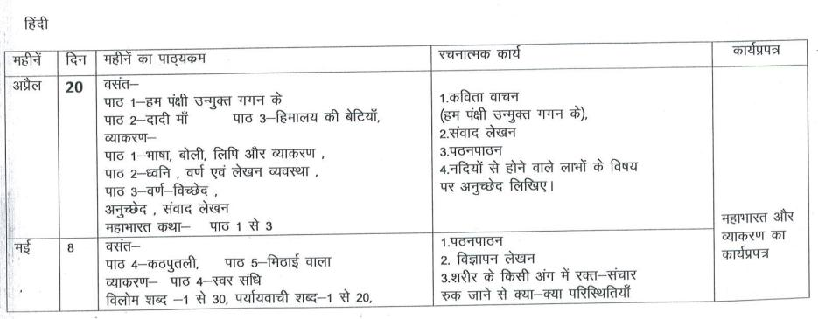

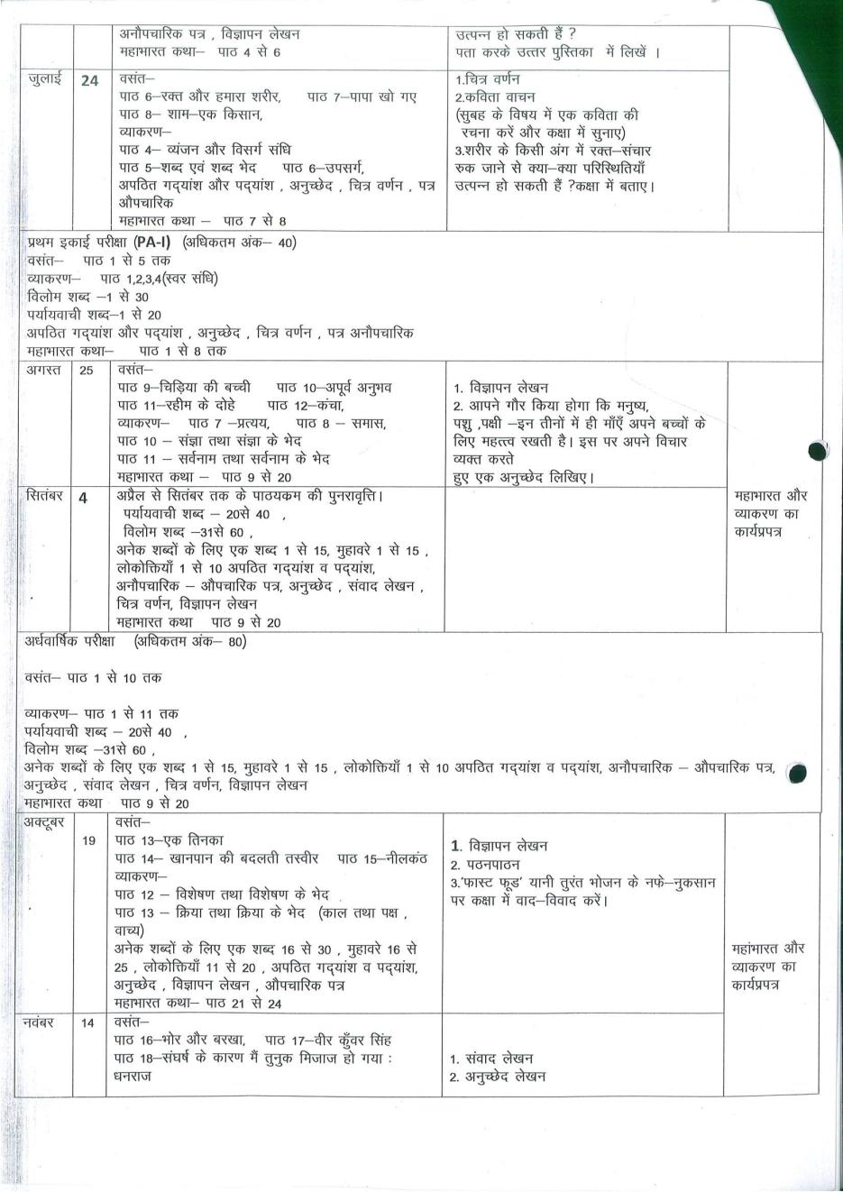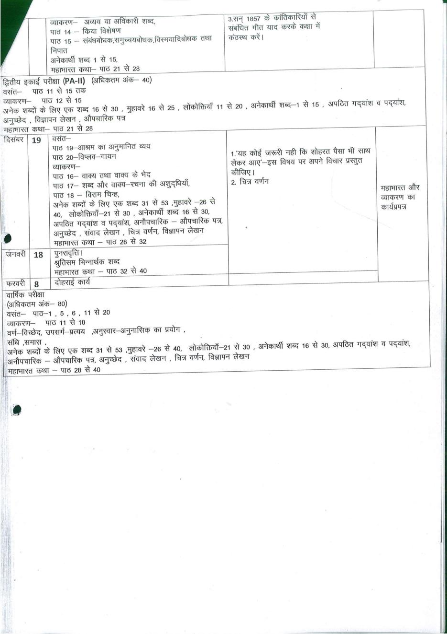
Maths
Month & Days | Syllabus Content |  |  | Chapters covered by Activities(In Maths-lab Mannual ) | Work sheet
Apr.  (20) | Ch: - 1 . Integers  Ch : - 2 Fraction and Decimal |  |  | Activity 1: To Subtract integers.  Activity 2: To find fraction equivalent to given fraction | Solve Drill exercise for chapter given school in book set
May & July.  (8+25) | Ch : - 3 Data Handling  Ch : - 4 Simple Equations |  |  | Activity 3: Addition of Decimals. | Solve Drill exercise for chapter given school in book set
WRITTEN EVALUATION SYLLABUS: PA. –I M.M. 40
Ch : - 1 . Integers Ch : - 2 Fraction and Decimal Ch : - 3 Data Handling
Ch : - 4 Simple Equations
Aug. & Sept  (23+22) | Ch : - 5 Lines and angles,  Ch : - 6 The triangle and its properties  Ch : - 7 Congruence of triangles.  Ch : - 8 Comparing Quantities |  | Activity 4: : To Make a Protector by paper folding  Activity 5: To establish the fact that triangle is the most rigid figure. |  | Solve Drill exercise for chapter given school in book set
WRITTEN EVALUATION SYLLABUS: Half Yearly M.M. :80
Ch : - 1 . Integers Ch : - 2 Fraction and Decimal Ch : - 3 Data Handling
Ch : - 4 Simple Equations Ch : - 5 Lines and angles, Ch : - 6 The triangle and its properties Ch : - 7 Congruence of triangles.
Oct. & Nov.  (19+21) | CH : - 9 Rational Numbers  CH : - 10 Practical Geometry  CH : - 11 Perimeter and area |  | Activity 6: To find the sum of fraction with different denominator. Activity 7: To obtain formula for the area of rectangle |  | Solve Drill exercise for chapter given school in book set
WRITTEN EVALUATION SYLLABUS: P.A.- II M.M. 40
CH : - 8 Comparing Quantities(Only Exercise -8.1,Ex-8.2)
CH : - 9 Rational Numbers CH : - 10 Practical Geometry (Only Exercise -10.1,Ex-10.2)
Dec. & Jan.  (12+23) |  | CH : - 12 Algebraic Expressions  CH : - 13 Exponent and power | Activity 8: To verify the algebraic identity  (a + b)² = a² + 2ab + b² |  | Solve Drill exercise for chapter given school in book set
Feb.  (21) |  | CH : - 14 Symmetry  CH : - 15 Visualizing solid shape | Activity 9: To obtain the lines of symmetry of a figure (say a rectangle) by paper folding. |  | Solve Drill exercise for chapter given school in book set
WRITTEN EVALUATION SYLLABUS: Yearly Exam.: M.M. 80
All the Chapters (Ch .No -1 to Ch .no 15)

Science
Month | Days | Chapters To be covered | Activity/  Practicals | Chapters in the  form of Assignment
April | 18 | CH-1 Nutrition in plants  CH- 2 Nutrition in Animals CH- 4 Heat
May | 8 | CH -5 Acids, Bases and Salts | CH-3 Fibre to  Fabric | CH-3 Fibre to  Fabric
July | 10 | CH -6 Physical and Chemical Changes
WRITTEN EVALUATION SYLLABUS: PA I
CH- 1, 2, 4, 5,6
Aug. | 21 | CH- 7 Weather, Climate and Adaptation of  Animals to Climate  CH-8 Winds, Storms and Cyclones  CH- 9 Soil
Sep. |  | Revision
WRITTEN EVALUATION SYLLABUS: Half Yearly (80)
CH – 1, 2, 4, 5, 6,7, 8, 9
Oct. | 17 | CH-10 Respiration in Organisms  CH- 11 Transportation in Animals and Plants  CH- 12 Reproduction in Plants
Nov. | 9 | CH- 12 Reproduction in Plants (cont.)  CH – 13 Motion and Time
WRITTEN EVALUATION SYLLABUS: PA II
CH – 10 CH -11 CH - 12
Dec. | 20 | CH – 14 Electric Current and its Effects  CH- 15 Light |  | CH- 16 Water: A  Precious Resource
Jan. | 19 | CH -17 Forests: Our Lifeline  CH- 18 Wastewater Story
Feb. |  | Revision
WRITTEN EVALUATION SYLLABUS: Yearly Exam (80)
CH – 6, 9, 10, 11, 12, 13, 14, 15, 17, 18

S.st
Month |  | Days |  | Chapters To be covered | Activity/ Project work | Worksheet  Chapter  wise
April |  | 25 |  | Geo. L-2 Inside our Earth  Geo. L-3Our changing earth  Pol. L-2 Role of the Government in health | His. L-1Tracing  changes through a  thousand Years  L-5 Rulers and  Buildings  Geo. L-1 Environment  L-7 Human environment  Settlement,  transport and communication  Pol. L-1 On Equality  L-5 women change  the world  L-10 struggle for  equality  Diagrams ,  Crosswords ,  Flow Charts,  Map work,  posters ,  Brochures ,  Debate &  Group Discussion  ( as per the  requirement  of the chapter ) | Assignments  &  worksheets  (as per  Requirement  of the chapter  will be  provided)
May |  | 8 |  | His. L-2 New kings and kingdoms
July  (Exams) |  | 25 |  | His. L-3 The Delhi Sultanate  Pol. L-3 How the states Government works
WRITTEN EVALUATION SYLLABUS: PA I (40)
4 chapters
His. – 2 Geo. – 2,3 Pol .- 2
Aug. | 21 |  | His. L-4 The Mughal Empire  Geo L-4 Air L-5 water
Sep | 21 |  | Geo L-6 Natural vegetation and wildlife
WRITTEN EVALUATION SYLLABUS: Half Yearly (80)
8 chapters
His. – 2,3,4 Geo. –4,5,6 Pol. – 3,6
Oct. | 19 |  | His. L-8 Devotional path to divine  Geo. L-8 Life in tropical and sub tropical region  Pol. L-6 understanding media
Nov.  (Exams) | 21 |  | His. L-10 New political formation in the  18th century
WRITTEN EVALUATION SYLLABUS: PA II (40)
4 chapters
His.-8 Geo.- 8,9 Pol.- 8
Dec. | 20 |  | Geo. L-9 life in the temperate grassland  Pol. L-8 Markets around us
Jan. | 20 |  | Geo. L-10 Life in desert
Feb. | 11 |  | Revision
WRITTEN EVALUATION SYLLABUS: Yearly (80)
Whole syllabus (April – January)

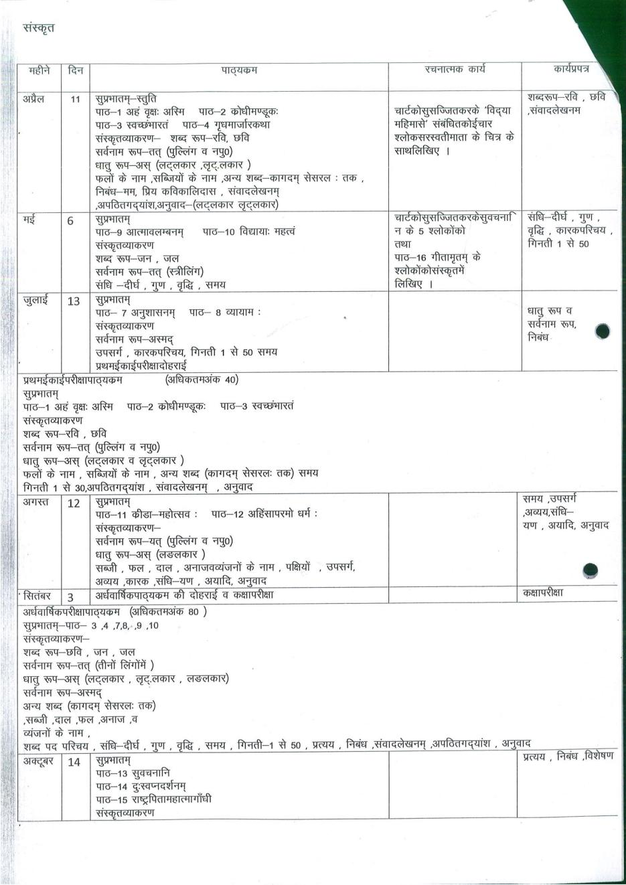Comp.
Month |  | No. of Days | Content | Practical
April |  | 18 | Ch – 1 : Formulas In Excel 2016 | Excel : Using formulas, error results, auto sums, functions library
May |  | 8 | Ch – 2 : Creating charts in Excel 2016 | Excel : types of charts, components of a chart, creating chart, sparklines
July |  | 10 | Ch – 3: Computer Lang. & the Number System | Practical of excel
WRITTEN EVALUATION SYLLABUS: P.A. – I M.M 30
Ch – 1,2
Aug |  | 20 | Ch – 4 : MS Small Basic Looping Statements  Ch – 5 : Smartphones, Tablets, and Apps |  | Small Basic : loops and graphics- For..End for,  while ..EndWhile, Graphics windows
Sep |  |  | Revision |  | Small Basic : loops and graphics- For..End for,  while ..EndWhile, Graphics windows
WRITTEN EVALUATION SYLLABUS: Half Yearly Exam M.M. 80
Ch – 3,4,5
Oct | 17 |  | Ch – 6 : More Tools in Animate CC  Ch – 7 : Advanced Animations in Animate CC |  | Animate: Gradient fill, changing the center point, changing the width, Creating motion in different shapes, Use of filter
Nov | 9 |  | Revision
WRITTEN EVALUATION SYLLABUS: P.A. – II M.M. 30
Ch – 6,7
Dec | 20 |  | Ch – 8: Introduction to HTML 5 |  | HTML : HTML Editors, coding, line break element
Jan | 19 |  | Ch – 9 : Basic HTML 5 Commands |  | HTML : Elements, text & font properties, setting-margins & borders
Feb |  |  | Revision
WRITTEN EVALUATION SYLLABUS: Yearly Exam M.M. 80
Ch – 7,8,9

G.K.
Months | Days | Content
April | 5 | Page no. 3 to Page no. 15
May | 3 | Page no. 16 to Page no. 20 and Page no. 67
July | 4 | Page no. 21 to Page no. 24 and Page no. 68 Revision
Written Evaluation Syllabus: PA-1 M.M.-30
Page no. 3 to Page no. 20 and Page no. 67
August | 7 | Page no. 25 to Page no. 37 and Page no. 70 Current Affairs
September |  | Revision
Written Evaluation Syllabus: Half Yearly Exam M.M.-40
Page no. 21 to Page no. 37, Page no. 68 and Page no. 70 Current Affairs
October | 6 | Page no. 38 to Page no. 50 and Page no. 69
November | 2 | Page no. 51  Revision
Written Evaluation Syllabus: PA-II M.M.-30
Page no. 38 to Page no. 50 and Page no. 69
December | 8 | Page no. 52 to Page no. 66
January | 7 | Page no. 71 and 72  Current Affairs, Revision
February | 2 | Revision
Written Evaluation Syllabus: Yearly Exam (February) M.M.-40
Page no. 51 to Page no. 66 Page no. 71 and 72 Current Affairs

Art & Craft
Month | No. of Days | Pages of Art Book | Activity
April | 20 | Nature study  Still Life | Collage art
May | 8 | bird Study
July | 24 | Landscape Sketching | logo Design
August | 25 | Poster design | D Art
September | 4 | Revision
WRITTEN EVALUATION SYLLABUS: Half yearly
nature study,landscape,still life , logo design
October | 19 | composition | Quilling flower
November | 14 | Cartoon character portrait
December | 18 | Folk Art | calliography
January | 10 | Warli Art
February |  | Revision
WRITTEN EVALUATION SYLLABUS: Yearly ---
composition,cartoon character,folk art, quilling art

FRENCH

LES MOIS | LE GRAMMAIRE | LES VOCABULAIRES | LES DIVERS
AVRIL | 1.Les verbs er, avoir et etre.  2. comment designer les choses en francais. | 1. Le bureau de poste  2. Les nombres ordianux.  3. Les salutations. | 1.Les formations du phrases avec les verbs avoir et etre.  2. Les faits
MAI | 1.Les verbs aller et voulvoir.  2.Les prepositions. | 1.Le generale.  2. Les magasins de disques. | 1.Les formations du phrases avec les verbs aller et voulvoir
JUILLET | 1.Les verbs faire et dormir.  2. Les petits mots qui signifient beaucoup. | 1. La banque.  2. Les noms de magasins. | 1.Les formations du phrases avec les verbs faire et dormir
PA1 (30) | 1.les verbs- etre, avoir, aller et faire.  2. comment desingner les choses en farncais. | 1.Le bureau de poste  2. La banque  3. Les noms de magasins | 1. les nombres ordianux.  2. les salutations  3. les formations du phrases
AOUT | 1.les comptent. | 1.Les magaisn de photographie | 1.l’comprehension d’ecrit.
SEPTEMBRE | 1.les articles  2. les adjectifs | 1. les legumes et les fruits.  2. quel jours sommes-nous? | 1. les formations du phrases avec l’aide de legumes et fruits.  2. decrire une personne.
HALF YEARLY(40) | 1.les articles.  2. les adjectifs | 1.Les magaisn de photographie. | 1,.les comptent  2.l’comprehension d’ecrit
OCTOBRE | 1.re and ir verbs  2.l’exercises sur le sujet articles. | 1.Le jours de la semiane et le mois  2. les professions | 1.l’comprehension d’ecrit
NOVEMBRE | 1.les formations du phrases.  2.l’exercises sur le sujet adjectifs | 1. les vetements.  2. la table et encore du vacbulaire. | 1.l’comprehension d’ecrit
PA 2 (30) | 1.les formations du phrases.  2.Les excerises sur le sujet verbs | 1.Les jours de la semiane et les mois  2. les professions.  3. les vetements | 1..l’comprehension d’ecrit
DECEMBRE | 1.les formations du phrases.  2.Les excerises sur le sujet verbs | 1.la voiture.  2. voyages en avion .  3. les magasins d’alimentation. | 1.l’comprehension d’ecrit
JANVIER | La revision | La revision | La revision
YEARLY | 1.les formations du phrases.  2.Er , ir et re verbs  3. articles  4.adjectifs  5. irregular verb | 1.la voiture.  2. voyages en avion  3.les magasins d’alimentation | 1.l’comprehension d’ecrit.  2. les nombres ordinaux et cardinaux.

